**DAILY ONLINE ACTIVITIES SUMMARY**

|  |  |  |  |  |  |  |  |  |
| --- | --- | --- | --- | --- | --- | --- | --- | --- |
| **Date:** | **14-6-2020** | | | | | **Name:** | **Likhitha.M** | |
| **Sem & Sec** | **6th sem ‘A’** | | | | | **USN:** | **4al17cs046** | |
| **Online Test Summary** | | | | | | | | |
| **Subject** | | **None** | | | | | | |
| **Max. Marks** | | **-** | | **Score** | | | **-** | |
| **Certification Course Summary** | | | | | | | | |
| **Course** | **Front end Development- HTML** | | | | | | | |
| **Certificate Provider** | | | **Great learning** | | **Duration** | | | **3 days** |
| **Coding Challenges** | | | | | | | | |
| **Problem Statement:**  1. Write a C Program to implement the Binary  2.write a java program to remove specific characters in the String If the original string is "Learning never stops" and the user inputs string to remove "estp" then the it should print "Larning nvr o" as output . | | | | | | | | |
| **Status: completed** | | | | | | | | |
| **Uploaded the report in Github** | | | | | **yes** | | | |
| **If yes Repository name** | | | | | **https://github.com/likhithaMantaral/Daily-status** | | | |
| **Uploaded the report in slack** | | | | | **yes** | | | |

Certification Course Details:

**Heading tags:**

Introduce Headings into the page

**Hr and Br tags:**

Some other simple tags:-

**Hr**- Horizontal rule, which is used to draw a line.

**Br**- Break rule, which is used to give a line break in HTML.

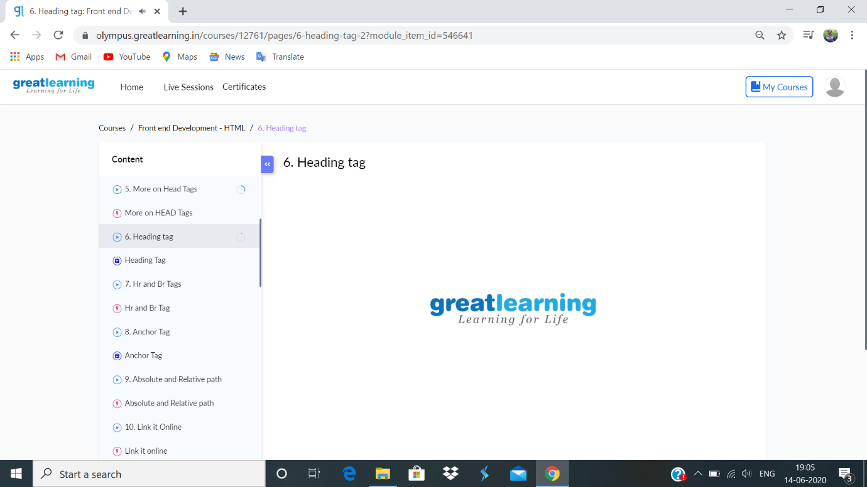

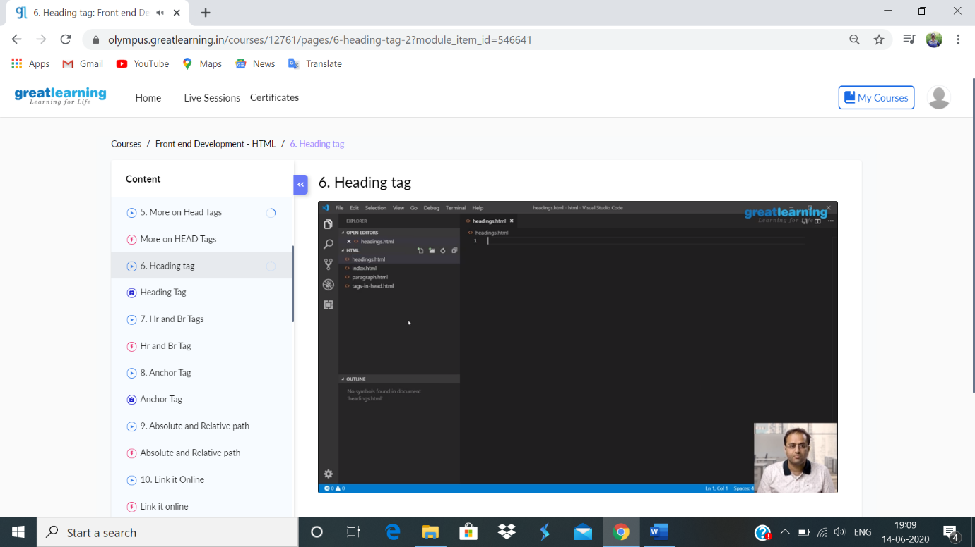

**Coding challenge:**

**1.**

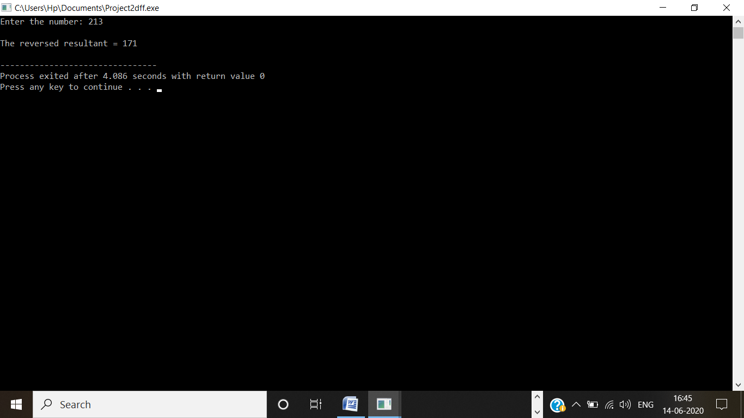

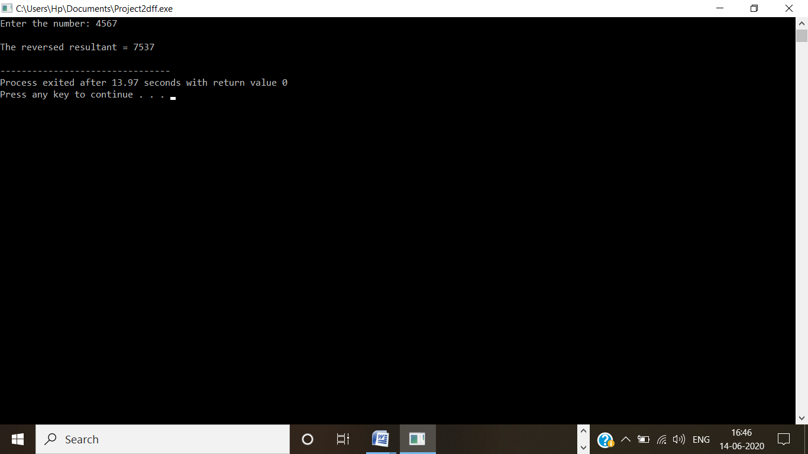

2.

